# Introduction to Programming

## Exercises

### Week 1

Prior to attempting these exercises ensure you have read thelecture notes and/or viewed the video, and also completed the practical. You may wish to use the Python interpreter in interactive mode to help work out the solutions to some of the questions.

Download and store this document within your own filespace, so the contents can be edited. You will be able to refer to it during the test in Week 6.

Enter your answers directly into the highlighted boxes.

For more information about the module delivery, assessment and feedback please refer to the module within the MyBeckett portal.

**_________________________________________________________________________**

## ©2021 Mark Dixon / Tony Jenkins

**_________________________________________________________________________**

What is the name of the programming language that we will be using on this module? What version of the language are we using?

*Answer:*

The name of the program language is ‘Python’.

We will be using the version 3.11.2

**_____________________________________________________________________**

A computer program takes some *input*, performs some *processing* then…. what?

*Answer:*

Gives output and stores it if needed.

**_________________________________________________________________________**

What generation of programming language is *machine code*?

*Answer:*

First Generation

**_________________________________________________________________________**

Which of the following is known as a second generation programming language?

* C++
* Java
* Assembly
* R
* Python

*Answer:*

Assembly

**_________________________________________________________________________**

State one problem associated with writing code in Assembly Language.

*Answer:*

Syntax is difficult to remember.

**_________________________________________________________________________**

What generation of programming language is *Python*?

*Answer:*

Third Generation

**_________________________________________________________________________**

What is the purpose of a *compiler*?

*Answer:*

Compiler is used to translate a programming language code into machine language code.

**_________________________________________________________________________**

The Python interpreter uses an interaction model called **REPL**. What does this stand for?

*Answer:*

REPL stands for Read, Evaluate, Print and Loop.

**_________________________________________________________________________**

Is it true that Python development always has to take place using *interactive-mode* within the Python interpreter?

*Answer:*

No it is not true.

**_________________________________________________________________________**

What does the term IDE stand for?

*Answer:*

The term IDE stands for Integrated Development Environment.

**_________________________________________________________________________**

What is the main reason why programmers use *code libraries*?

*Answer:*

Programmers use code libraries to save time and be able to use reusable classes or functions.

**_________________________________________________________________________**

The Python language is often used in the field of *data-science*. What other language specifically supports *data-science*?

*Answer:*

SQL specifically supports data-science.

**_________________________________________________________________________**

An expression within a programming language consists of *operands* and *operators*.

Given an expression such as: 20 + 10, which part of this is the *operator*?

*Answer:*

‘+’ is the operator.

And, which part of this is the *operand*?

*Answer:*

The operands are ‘20’ and ‘10’.

**_________________________________________________________________________**

Within Python, what calculation is performed by the ‘*’ operator?

*Answer:*

‘*’ is used for multiplication.

And, what calculation is performed by the ‘/’ operator?

*Answer:*

‘/’ is used for division.

And, what calculation is performed by the ‘**’ operator?

*Answer:*

‘**’ is used for exponentiation.

**_________________________________________________________________________**

Using the information about expression evaluation provided in the related tutorial, evaluate each of the following expressions **in your head** and type the result in the answer boxes below. Remember that an operator precedence is applied, but can be overridden by the use of parentheses.

a) 100 + 200 - 50

*Answer:*

250

b) 10 + 20 * 10

*Answer:*

210

c) 20 % 3

*Answer:*

2

d) 20 / (2 * 5)

*Answer:*

2

e) 20 / 2 * 5

*Answer:*

50

f) 10 * 2 + 1 * 3

*Answer:*

23

g) 5 + 10 ** 2

​​​*Answer:*

105

h) (10 + 2 / 2) + ((10 * 2) ** 2)

*Answer:*

411

**_________________________________________________________________________**

Use the Python interpreter to input and then execute a simple Python expression that adds the three numbers 100.6, 200.72 and 213.3, then write the result in the answer box below.

*Answer:*

514.62

**_________________________________________________________________________**

Use the Python interpreter to input and then execute a simple Python expression that multiplies the three numbers 20.25, 100 and 23.9, then write the result in the answer box below.

*Answer:*

48397.5

**_________________________________________________________________________**

Use the Python interpreter to input and then execute a simple Python expression that divides the number 10 by 0, then write the result in the answer box below.

*Answer:*

ZeroDivisionError: division by zero

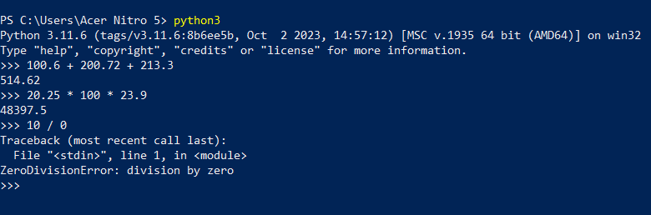

**_________________________________________________________________________**

What type of error is typically easier to identify? A *syntax* error? Or a *logical* error?

*Answer:*

Syntax error is typically easier to identify.

**_________________________________________________________________________**

What type of message is used by the Python interpreter to report run-time errors?

*Answer:*

The Python interpreter uses ‘Traceback’ message to report run-time errors.

**_________________________________________________________________________**

What command can be used to exit the Python interpreter?

*Answer:*

‘exit()’ can be used to exit the Python interpreter.

**_________________________________________________________________________**

## 

## **Exercises are complete**

Save this logbook with your answers. Then ask your tutor to check your responses to each question.